VCSE organisations are facing an increasingly challenging operating environment. From the cost-of-living crisis to the effects from events overseas, there is growing demand and pressure on VCSE organisations to serve an increasing number of people in need. This report offers analysis, insights, and the start of a discussion into the situation and experiences faced by VCSE organisations. Following initial general analysis, there is sub analysis based on sizes and services of VCSE groups. Discussion will cover groups relationships with statutory organisations, recruiting and retaining volunteers and the key themes emerging. A series of recommendations are offered on how to support VCSE organisations to enable them to help manage these issues.
CVS South Gloucestershire - Shape of the Sector Report 2023

Summary of the structure of the report
The report begins with a general analysis of all 57 responses covering areas such as, access to funding, level of demand for services and hopes for the future.
This is followed by a deeper analysis looking at specific groupings of organisations. The first of these is based on the size of organisations in respect to turnover: £0 - £50,000 / £50k - £1Million / over £1m. Second is separation of groups into different subsectors of services provided (list and explanations of subcategories in Appendix 1 and discussed in detail later in the report).
The purpose of this segmented analysis is to see whether VCSE organisations face similar experiences regardless of size (by income) and to see if different areas of service are struggling more than others and if so, in any certain areas.
The information gathered through this research has been used to draw conclusions on the current state of the VCSE sector in South Gloucestershire. Alongside, developing recommendations to South Gloucestershire Council and other partners both public and private organisations, as well as the sector itself, on reasonable steps that could be taken to ensure the long-term viability and sustainability of a vital, capable, and evolving VSCE sector in South Gloucestershire which serves the needs of those in the community.

Whole Sector Analysis
Overview of organisations represented in this report

Beneficiaries covered by the VCSE sector of South Gloucestershire and their place in improving the health and wellbeing of the community
All 21 categories of beneficiaries were covered by our respondents, illustrating the diverse landscape of beneficiaries that the VCSE organisations of South Gloucestershire are supporting. In addition to these 21 categories we provided, some organisations indicated that they worked with additional beneficiary groups in their responses:
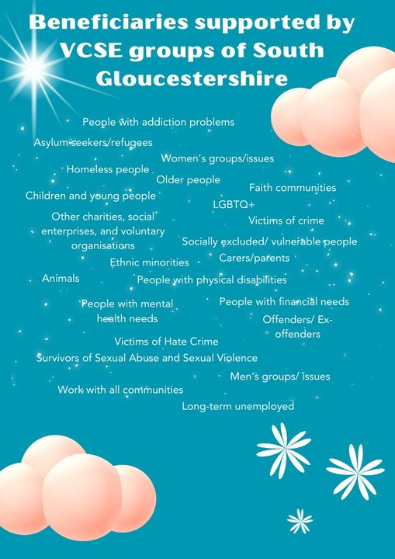
100% of respondents stated their group has an impact on improving people’s health and independence.
96% of respondents stated they help to reduce social isolation.
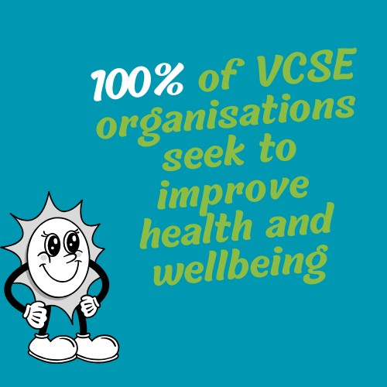
When selecting areas in which to focus their attention and develop their impact in, improving health and independence, and reducing social isolation scored highest at 55% and 49% respectively. This illustrates the sector’s interest and potential in helping to improve health and wellbeing in our communities (keeping people well).
The VCSE sector can play a pivotal role in improving people’s health and wellbeing as they have a strong presence and good relationships with the communities that they serve.
The majority of organisations need further support to work in partnership with the statutory sector.
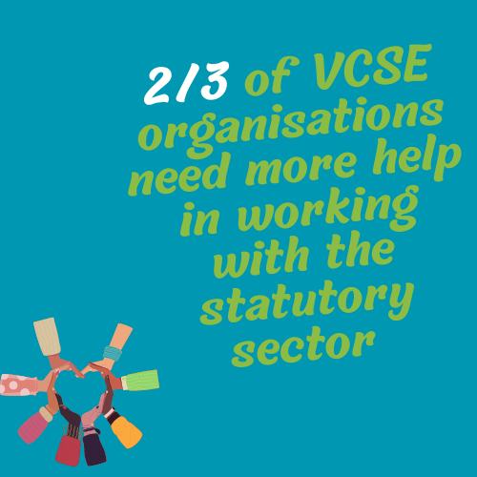
65% of respondents agreed that more support is needed for their organisation to work in partnership with the statutory services.
If we want to take full advantage of the VCSE sector’s potential to contribute to prevention in health and social care, then we’ll need to develop the relationship between the VCSE sector and statutory service providers so that they understand each other’s needs, aims and expectations in order to work effectively together. Having positive and effective relationships will be key to success in this transition with the VCSE sector playing an increasingly prominent role in health and social care landscape.
CVS South Gloucestershire and VCSE ‘infrastructure’ can play a key role in this as a link between the VCSE sector and statutory service providers. The close working relationship that CVS South Gloucestershire has with both sectors means that we are in a strong position to facilitate the needs of both sides and to help find common ground in aims and objectives as well as practical ways to evolve how the sectors work together.
Access to funding is not increasing at the rate that the increase in demand for VSCE services are:
80% of respondents stated they’ve seen an increase in demand for their services in the last 6 months.
49% are also struggling to meet this demand.

Over the last 6 months, 24% of respondents reported that their financial position had worsened and 36% advised that it has stayed the same.
This demonstrates how although most organisations have seen an increase in demand for their services and nearly half are now struggling to operate, for the majority funding has either stayed the same or decreased, therefore restricting their capacity to meet demand.
87% of respondents expect demand for their services to continue increasing over the next 6 months. Within this figure, 49% expect it to increase a little and 38% to increase a lot. Nevertheless, when asked about how they expect their financial position to change over the next 6 months, 35% stated they expect their funding to stay the same, 20% think they will receive a decrease in funding, 40% say they expect a little increase in funding but only 1 respondent reported an expectation for funding to increase a lot in the next 6 months.
Although most groups expect an increase in demand for their services, they do not believe their income will grow to match this. This is only going to lead to negative outcomes for both the beneficiaries they serve and the organisations themselves, potentially causing burnout, loss of volunteers and staff or even the closure of some organisations.
Finance sub-analysis
Groups: £50k and under
None of these groups said that recruiting and retaining volunteers was easy or very easy. Significant help is needed in this area.
66% of organisations agree that ‘more support is needed for your organisation to work in partnership with the statutory services’.
Key themes
The need to keep people/volunteers interested and engaged with VCSE organisations and their work and to promote the benefits of volunteering or working in the VCSE.
Ensuring long-term viability of the organisation by increasing engagement, securing funding and much needed volunteers to run organisations and keep them open.
Some respondents mentioned that there is a need to promote their services more effectively to make people aware of their work, but the vast majority said there is already both a need and a demand for them to expand their offering, but that they need access to funding and manpower to be able to meet this.
There were also mentions by multiple respondents of wanting to collaborate more with peer organisations for funding opportunities, increasing engagement with their cause, and raising awareness.
Groups: £51k to £1million
70% of organisations agree that ‘more support is needed for your organisation to work in partnership with the statutory services’ while only 13% disagreed.
9% of respondents in this category reported finding volunteer recruitment and retainment easy, which is more positive than for smaller groups however, 47% still find difficulty or extreme difficulty in this task.
This is an area of high need for guidance and support to be offered to groups.
Key themes
Themes found were similar to the previous group. One being to ensure long-term sustainability of the organisation through recruiting staff and volunteers and securing income needed to maintain operations and premises.
Increasing demand for services with growing running costs are both leading to mounting pressures on capacity.
There were numerous mentions of the need to promote services more effectively alongside a requirement for more support around volunteer management and workforce development. This goes together with comments about a lack of long-term funding availability having implications of being unable to develop long-term business plans and decision-making.
There is also a need for VCSE organisations to develop their workforce (both paid and unpaid) to develop organisations and their practices and to better support beneficiaries, however they find themselves operating in an environment where they don’t have any guarantees about long-term funding which can lead to difficulties in ensuring the necessary support and training is given to their teams when it is needed.
Alongside this, these groups also mentioned a need and demand for effective volunteer management to offer each of their volunteers tailored support and the best possible experience to increase likelihood of continuing in their roles and/or referring a friend/family member to volunteer with them too. VCSE organisations recognise the big impact that volunteers can have on organisations in driving their mission and enhancing the lives of beneficiaries. They want to develop their capacity in this area, but they need the necessary support to be able to do so.
These groups want to collaborate more with other organisations.
Groups: £1m+
80% advised they are finding it difficult to recruit and retain volunteers, even at this level. This is a key issue affecting VCSE organisations of all sizes.
40% agreed that ‘more support is needed for your organisation to work in partnership with statutory services’ with 40% unsure on this issue and only 20% disagreeing.
Key themes
Funding that they are receiving is not increasing to meet the growing costs of running their premises.
There is increasing demand on services with service-users presenting with more complex needs, adding additional pressures on team members (both paid and unpaid).
Sub-sectoral analysis
In the classification of organisations into subcategories consideration was given for the organisations main purpose and their offerings. Many VCSE organisations undertake multiple activities in parallel and have been classified based on their primary activity. We’ve done this so we can compare similar groups and look for common themes. Explanation for each of the themes chosen is in Appendix 1.
Youth work
89% agree that ‘more support is needed for your organisation to work in partnership with the statutory services’.
The majority (67%) felt indifferent around volunteering recruitment and retainment. Of the remaining third: 22% found it difficult and the remaining 11% found it extremely difficult.
Key themes
There is an ever-increasing demand for these services and many organisations discussed the desire and need to expand, but advised they would first need to secure the funding and manpower to be able to meet the true need.
These organisations are concerned about ever-rising costs of running premises and operations. There is increasing need for their services, but their resources are diminishing and funding is not stretching as far as before due to rising costs.
Many of these organisations discussed an increasing need to support staff who are being faced with more complex clients and working in an increasingly challenging environment.
Education and Training
50% agree that ‘more support is needed for your organisation to work in partnership with the statutory services’. The other half disagreed that they need more help in this area.
100% however, are facing difficulties in recruiting and retaining volunteers.
Key themes
The need to secure funding and capacity to meet the ever-increasing need and ensure long term sustainability.
There is a desire to collaborate more to access funding and increase the impact they make in their communities.
Environment and Conservation
100% agree that ‘more support is needed for your organisation to work in partnership with the statutory services’.
100% are also facing difficulties in recruiting and retaining volunteers.
Key themes
There is a lack of volunteers and management capacity in these organisations which is affecting their ability to run effectively and ensure long-term sustainability.
There are concerns about sourcing long-term income, the lack of manpower and time to apply for the grant funding that is needed to ensure continued success.
Advocacy and Justice
100% agree that ‘more support is needed for your organisation to work in partnership with the statutory services’.
All respondents in this category were unsure or felt that recruitment and retention of volunteers was not applicable to them.
Key themes
There are strong concerns around the need to secure necessary funding and manpower to meet strategic objectives and identified need.
Arts and Heritage
50% agree that ‘more support is needed for your organisation to work in partnership with the statutory services’. With 33% being unsure and 17% disagreeing.
All but one organisation (83%) are finding volunteer recruitment and retainment difficult.
Key themes
To ensure survival and long-term sustainability of these organisations there is a need to increase engagement to ensure people are aware of their work and consider joining as new volunteers as many of the current volunteer-force are in the older age groups and are increasingly unable to offer the level of support needed by their organisations.
Support is needed around volunteer management as many of these organisations are heavily reliant on volunteers to keep their premises running. They need to build capacity to manage volunteers who run operations and premises, effectively and appropriately.
Many are finding it harder to secure grants due to growing competition and needing more income to run activities and pay for premises due to increasing costs.
Some respondents also mentioned a need for better promotion of what their organisations offer in our communities to increase engagement and to stay open.
Health and Wellbeing
71% agreed that ‘more support is needed for their organisation to work in partnership with the statutory services’ with only one disagreeing and other respondents being unsure.
50% are finding difficulties in recruiting and retaining volunteers to run in an increasingly pressurised and challenging environment. Only one organisation reported this being easy.
Key themes
There is increasing complexity in cases that these organisations are being presented with.
The increasingly challenging operating environment is leading to difficulties in recruiting and retaining the paid staff needed to run these organisations.
Demand has increased and is continuing to do so but funding is not catching up at the same rate. This is resulting in organisations wanting and desperately needing to expand but needing more support and funding to do so.
Many are relying on insecure short-term funding which is leading to staff insecurity and inability to retain the necessary staff and to train them well to run their services and support beneficiaries effectively. This lack of long-term funding support is harming their ability to run. Having a skilled and experienced staff offers many benefits to service users and the wider team/network offering related services, however an environment of short-term insecure funding is hampering this possibility.
Although many of these organisations discussed an ever-growing demand for their services some did mention the need for spreading awareness and better promotion of their services in the community. Alongside this, these organisations wanted to collaborate more often and more effectively in running services and meeting the needs of their service users. These ambitions tie-in with those of the health service’s Integrated Care Board and the wider NHS in wanting the VCSE sector to play a pivotal role in providing wellbeing, health and support services within their communities to improve outcomes and quality of life for all.
Signposting and Advice
67% agree that ‘more support is needed for your organisation to work in partnership with the statutory services’. The remaining respondents were unsure about the need for support.
83% are finding difficulties with volunteer recruitment and retainment.
Key themes
Organisations are facing huge increases in demand for their services and increasing complexity in cases they encounter.
Although there are huge increases in demand, their funding is being cut so there is concern about securing much-needed long-term and core funding to run their services effectively to meet this demand. Organisations have reported that they are increasing their own fundraising capacity to try and address this shortfall and reach as many clients in need of support as possible, but they mention they are concerned that the current funding environment will lead to increased competition between VCSE organisations for fundraising.
These organisations also mentioned a need for workforce development. Team members (both paid and unpaid) need more in-depth and specialised training to effectively manage the increasingly complex cases and queries that they are presented with to ensure they are meeting their clients’ needs.
Community Development/Activities
43% agree that ‘more support is needed for your organisation to work in partnership with the statutory services’. 14% disagree and 43% were unsure.
43% are finding difficulties with volunteer recruitment and retainment. Only one respondent reported this being easy.
Key themes
There is concern over increasing running costs for energy, supplies etc and the need to secure further income just to stay afloat and keep premises open and operations running.
Some of these organisations advise that there is a need to better promote their services within the community. They note how they need to increase awareness and engagement.
They also mention a lack of volunteers and hope that if they can increase awareness then more people will engage and volunteer to support their work and benefit the community.
On the other hand, some of these organisations who have developed a strong presence in their communities, recognise that there is a need to increase their offering by putting on more events, however, they need support with this as many are having to use emergency funding just to cover the shortfall that their regular funding has left due to the rising costs of running premises.
Looking Ahead
Still hopeful for the future
Although VCSE organisations have reported that they are facing a range of difficulties, 73% reported that it is very likely that they will still be operating this time next year and 18% said that they are quite likely to be.
VCSE organisations are hopeful for the future and want to continue to provide much-needed support to their beneficiaries.
Most organisations are also hopeful that they will achieve what they need in terms of increased numbers of volunteers - 56% reported that they expect to see volunteer numbers increase.
Conclusions and Recommendations
The VCSE sector of South Gloucestershire is continuing to provide many essential and beneficial services to the communities that they serve. Despite being under increasing strains and pressures, their resilience is exceptional. Nevertheless, it is essential that we both understand their needs in terms of support and deliver the help that the sector, and the people who keep the wheels moving, really need. The sector is critical to the wellbeing of our communities, and it must be sustained to keep providing vital services.
Facing increasing demand, many organisations are desperate to grow to meet the demands placed upon them, however they are unable to, due to insufficient and short-term funding hindering their chances of expansion or even making long-term plans. If we want to harness the true potential of the VCSE sector, then funding needs to be allocated on a longer-term basis.
Alongside this, our analysis identified key areas where VCSE groups need support. These are: volunteer recruitment, retention and management and building relationships with statutory sector partners.
We offer the following recommendations:
- More coordinated support needs to be provided to VCSE groups around volunteer recruitment and retainment as many groups of all sizes directly expressed needing support in recruitment and retainment of volunteers.
South Gloucestershire Volunteer Centre Partnership seeks to promote and develop volunteering. It comprises of Southern Brooks Community Partnerships who run three of the four volunteer centres covering Patchway, Filton and the Stokes, Yate and Kingswood then the fourth independently run Thornbury Volunteer Centre. The Partnership is supported by CVS South Gloucestershire and is part funded by South Gloucestershire Council.
The partnership and the public sector recognise the benefits that volunteering brings to volunteers, beneficiaries’, public services and society. We want to work together to develop and promote volunteering and make it more coordinated and accessible. We are also looking at this together on a West of England level via The Civil Society Partnership. During Covid we had a successful volunteer run vaccine centre programme across the West of England run by Voluntary Action North Somerset (VANS). We want to build on these capabilities.
There are opportunities now and we want to make this work to benefit the community of South Gloucestershire. We aim to work together, in partnership, to raise awareness and develop this opportunity.
- CVS South Gloucestershire will continue to build strong relationships with VCSE groups across South Gloucestershire to understand their needs and advocate them with statutory partners. Our Connections Officer, Hannah Hulbert, will continue to focus on this. We will continue to facilitate closer relationships between the VCSE sector and statutory services. We will also help support the VCSE sector in navigating their role in new ICB and wider NHS landscape.
Alongside this, we also have the newly revised Compact Agreement. ‘The Compact represents a shared recognition that collaborating in partnership can more strongly serve, represent, develop and promote the wellbeing of local people and communities in South Gloucestershire. The Compact has provided a framework for both public and VCSE sectors to recognise and respect the various roles, accountabilities and knowledge they bring in the service of their communities. It is intended to ensure that the smallest organisations are recognised and valued for their work in the community’(appendix 2). The Compact will continue to help us drive the Keep It Local approach and we will work with public sector and VCSE sector partners to continue to promote the principle of Keep it Local.
CVS South Gloucestershire also facilitate the South Gloucestershire VCSE Leaders Board. The Leaders Board aims to provide strong leadership for the voluntary and community sector (VCS) in South Gloucestershire. Its purpose is to gather leaders from the voluntary sector in order to offer strategic guidance for ensuring future sustainability of the sector, to provide support and sharing of expertise, and to act as an effective platform so that the voice and concerns of local communities and the VCS are heard by local government, policy makers and major funders.
CVS South Gloucestershire are a part of all these boards and support the sector to be represented and help to facilitate these working relationships.
- Funders need to recognise the true impact and monetary return that volunteer hours bring to organisations and commit to allocating funding for specific volunteer management roles. These roles are essential in ensuring volunteers receive the support they need and deserve and have a positive experience in their roles to encouraging a domino effect of volunteering practices in the community. Ensuring this will help VCSE organisations to reach their full potential and residents of the community to reap the benefits volunteering can offer to their wellbeing and sense of belonging in the community.
Many smaller organisations and arts/ heritage organisations heavily rely on volunteers so ensuring volunteers have good experience and help to grow community engagement in volunteering can mean the difference between long-term success and shutting operations down entirely for these organisations.
- We need to further develop the relationship between funders and VCSE organisations so the former can understand the need and benefit of allocating funding in a more flexible way and over longer periods of time. This allows VCSE groups to have the ability to respond to situations as they arise and develop and adapt their programmes accordingly to meet the true needs of their beneficiaries. We will continue to develop those relationships with funders to benefit VCSE groups of South Gloucestershire.
We will continue to support the VCSE sector of South Gloucestershire in the vital work that they are doing across the area. We will use the insight gained from this analysis to understand and advocate for the needs of the sector with our partners and stakeholders.

Appendices
Appendix 1
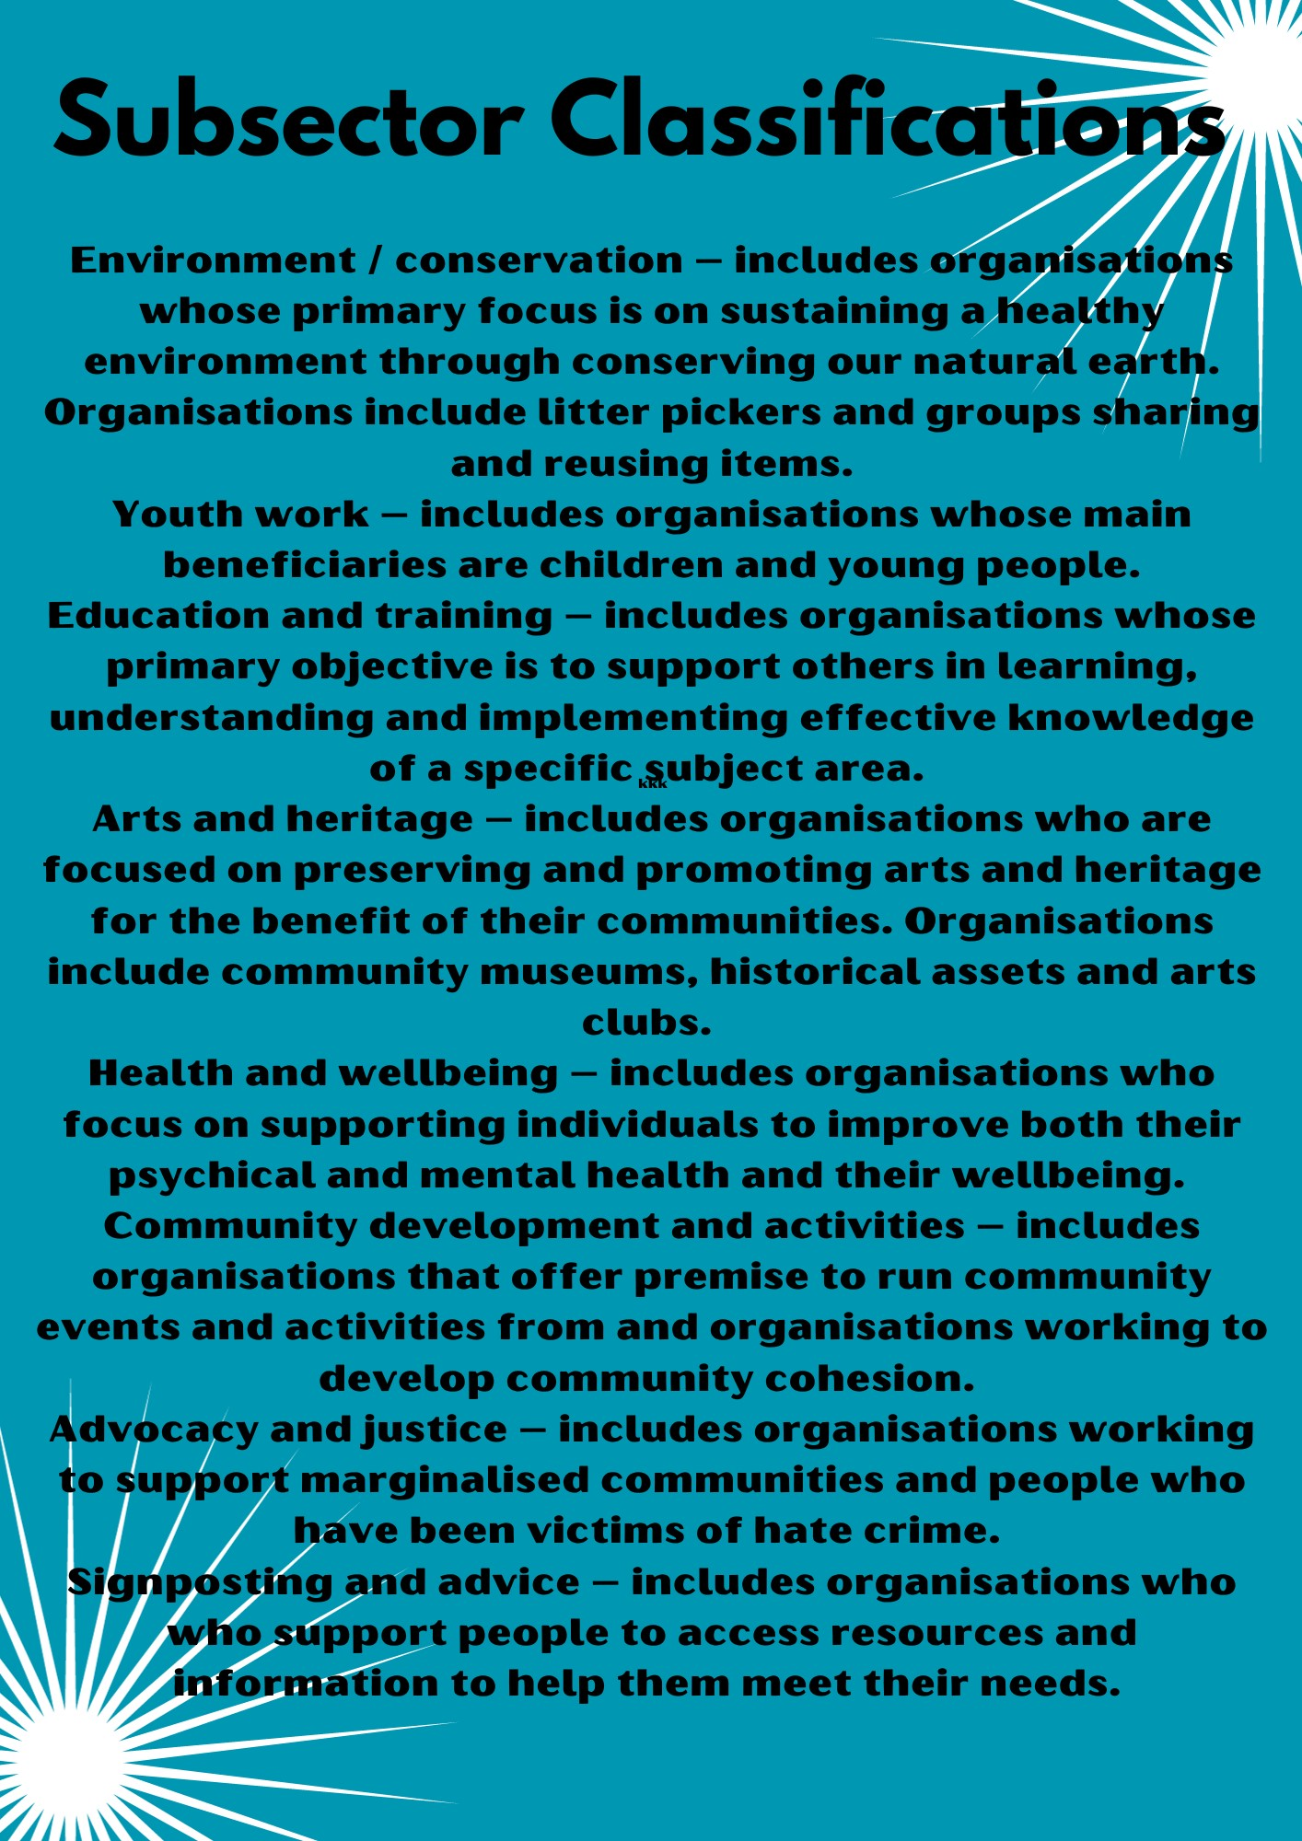
Appendix 2
The Power of Community: Keep it Local – South Gloucestershire Council 2022 New Compact consultation.pdf (southglos.gov.uk)
Justifications for definitions
The justification for changing the more typically seen category of health and social care to health and wellbeing is that this is holds a broader definition and allows for community transport and non-clinical providers to be included. The previous classification was more traditional in its definition. The new classification has developed as the VCSE sector offering has developed to meet the needs of the population.
For this work, we have followed the definitions for wellbeing and health which are provided by UNESCO. Wellbeing refers to a feeling of satisfaction with one’s life, in relation to the health, happiness and prosperity that they experience. Health more generally refers to care for the human body and measures taken to protect it from sickness and harm. This also includes, when needed, ability to access needed care and support. These definitions provided by UNESCO outline how one’s health and one’s wellbeing can be seen as interrelated and both of high importance.
Disclaimer: Statistics shown in this final report may have changed slightly from the initial preliminary findings that were presented at our AGM on 25/10/2023. This is due to obtaining further respondents since then and the finalising of the subcategories used for the analysis. See Appendix 1 above.

